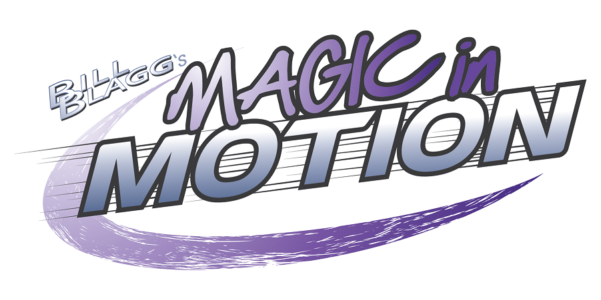

STUDY GUIDE

This study guide is designed to be used in conjunction with the live performance of Bill Blagg’s Magic in Motion show. Utilizing the resources in this guide will help you explore the experience of magic and live theater with your students. You will also be able to further your students’ understanding of the scientific laws that were taught during Bill Blagg’s Magic in Motion show and how bending those laws created magic! The goal of this guide is to further promote students to think “outside the box” and spawn their curiosity about how magic doesn’t exist without science!

© MOBB Productions, Inc.

About Bill Blagg

To say that Bill Blagg has had a magical life would be no exaggeration. He received his first professional magic book from his great-grandfather, which eventually led to building magic props with his dad. These early beginnings paved the way for Bill’s successful career in the art of magic.

After graduating from Carthage College (Kenosha, WI) with honors, Bill decided to pursue magic full-time. Today, Bill is one of the nation’s top touring magicians and performs close to 200 shows a year! In addition to his educational magic experiences (Magic in Motion & The Science of Magic), Bill also tours theatres across the country with his full-scale magic & illusion show, The Magic of Bill Blagg LIVE! which has been featured on ABC, CBS, NBC and FOX TV!

Having a love for both magic and science, Bill has created his one-of-a-kind, educational show Magic in Motion to teach students how magic wouldn’t exist without science. The show takes students on an exciting journey where they experience magic first-hand as the laws of science are defied right before their very eyes!

Bill lives in Milwaukee, WI with his wife Kristin (and their dog Daisy). When Bill is not performing magic, he can be found at his magic workshop creating new magic & illusions to thrill or educate his audiences!

Find out more about Bill and his magic at www.billblagg.com
About Magic in Motion

Bill Blagg’s Magic in Motion melds the fascination of magic with the wonders of physical science to create an unbelievable educational experience!

In this highly visual, interactive show, students will be on the edge of their seats as they experience how science creates magic right before their very eyes! Their jaws will drop in amazement as ordinary objects come to life, while others defy gravity with a simple clap of the hands!

Students will discover how magic is created from core scientific principles such as force, energy, friction, motion and more. Together with Bill they will explore these principles while bending the laws of science to experience the impossible! Science and magic will collide as students instantly become stronger than their teachers, stop moving objects with their minds and even make a teacher’s cell phone invisibly travel through time!

Magic in Motion is a magic filled, educational experience that is designed to inspire students to investigate how physical science is necessary for magic to exist while also playing an important role in their daily lives!

Find out more about Magic in Motion here: www.shawentertainment.com/magic-in-motion/

SCIENCE IN THE SHOW
Motion: a change in position compared to a place or an object that is not moving

Force: push or pull on an object. A force happens when two objects interact – that is, when one object does something to the other object. When the interaction stops, the force stops, too

Unbalanced Force: a force that causes a change in the motion of an object

Push: a force that moves an object away from something

Pull: a force that moves an object toward something

Gravity: a force that pulls objects toward each other

Mass: the amount of material that makes up an object

Energy: the power to make matter move or change

Friction: a force that slows or stops motion between two surfaces that are touching

Speed: rate of motion, or the measure of the distance an object travels in a certain amount of time

Velocity: how fast and in what direction an object is moving. Speed and direction of a moving object

Position: where an object is in relation to the objects around it

Simple Machine: something that uses force to make work easier

Fulcrum: fixed point on which a lever rests

Lever: a simple machine made up of a stiff bar that moves freely around a fixed point

Kinetic Energy: the energy of motion

Potential Energy: stored energy, energy caused by position

Pressure: (as in barometric pressure) the weight of the air

Newton’s Laws of Motion: three fundamental laws of classical physics developed by Sir Isaac Newton that describe the relationship between an object and the forces acting upon it

PRE-SHOW ENGAGEMENT
Physical Science Concept Review:

Conveyor Belt Graffiti Write

Review the following science concepts with students. Suggested concepts for each grade level are listed below.

Grades 2 and 3: push, pull, force, motion, gravity, simple machine

Grades 4 and 5: energy, motion, change, force, direction, gravity, mass, pressure

Grades 6 and 7: force, motion, law of gravity, mass, distance, direction, unbalanced force

- Write each science concept on a piece of chart paper.

- Break students into small groups. Give each group one of the chart papers. Make sure each student has a marker to write with (you may want each student in each group to have a different color marker for accountability purposes so they have to contribute to the graffiti write).

- Tell students that when you say go, they will silently write for one minute what they know or questions they have about the concept on the chart paper. Students may add on to other students’ thinking as well.

- After one minute, rotate the chart papers to the next group, hence the “conveyor belt”. Again, give one minute for students to jot their thinking, questions, and responses to others’ thinking.

- Continue until all groups have responded on all charts.

- When the original chart makes it back to the original group, have the group look at it and then report out any interesting thinking or questions that are written on the paper.

- Have a whole group or small group discussion about how these concepts may be connected to the show Magic in Motion. Have students jot some reflections about what they are going to expect from the show.

Nature of Science Review:

3-2-1 Bridge: How do magicians use science to create magic?

PART ONE

For this engagement, you are going to use the first part of a Visible Thinking Routine called 3-2-1 Bridge. You will begin this engagement before the show, and then complete the other half after seeing Magic in Motion.

- Set up several chart papers with the following organizer:
PART ONE  Initial responses:  How do magicians use science to create magic? | PART TWO  New responses:  How do magicians use science to create magic?
Three thoughts or ideas | Three thoughts or ideas
Two questions | Two questions
One analogy | One analogy
BRIDGE: Explain how your new responses connect to your initial responses.

- Break students into small groups.
- Have groups complete part one only. Students can share their thinking with the rest of the class when finished.
- Save the charts for after the show. Students will reflect on their new thinking after seeing Magic in Motion.

THEATER ETIQUETTE

Review theater etiquette with students before attending the show:
Theater etiquette is an important part of attending a live stage production. So that all patrons have an enjoyable experience at the theater, please share these guidelines with your students prior to attending the performance. Remind students to be respectful of the performers and other audience members by engaging in responsible behavior.

· You agree to be on time. Theater is great! It's live! It happens in the moment. You can't rewind it. You are an important part of the show and you need to be there from the very beginning. The performers are there, so you need to be there, too. Arriving 20 minutes before show time is the standard rule.

· You agree to use the restroom before the show starts to avoid getting up and disrupting the performance while it's happening. Once a class is seated, you may visit the restroom in small groups prior to show time. Young students must be escorted.

· You agree not to talk or whisper during the show. If you whisper to your friends during the show, you disrupt those around you, and quite possibly the performers. And, you might miss something!

· You agree to participate. This includes laughing at appropriate times, clapping in appreciation for the things you like, and doing other things when invited by the performers to do so. It also means paying attention to what's going on by listening and watching closely.

· You agree to turn off all cell phones and other gadgets that may make noise during the show.

· You agree not to take pictures or use recording devices of any kind during the show. The material performed on stage is copyrighted material, and therefore protected under copyright law from reproduction of any kind without written permission.

· Finally, you agree to give the performers a full curtain call. A curtain call is the performers' final bow at the end of the performance. It's your opportunity to show your appreciation for what they've shared with you. Please wait until all the performers have taken their final bow before exiting the theater. The ushers and your teacher will assist you in finding the best route out of theater!

POST-SHOW ENGAGEMENT
Nature of Science:

How did he do that?!?!

Break students into small groups to analyze one of the magic tricks Bill performed.

Have students create a visual that includes their explanations of the following:

- The science concepts represented before the trick.
- The science concept(s) that Bill defied to create the magic.
- The steps Bill may have taken to make the trick work.
- Variables that would cause the magic not to work.

Nature of Science Review:

3-2-1 Bridge: How do magicians use science to create magic?

PART TWO

For this engagement, you are going to use the second part of a Visible Thinking Routine called 3-2-1 Bridge. You will complete this engagement after the show.

- Pass out the original chart papers to the small groups:
PART ONE  Initial responses:  How do magicians use science to create magic? | PART TWO  New responses:  How do magicians use science to create magic?
Three thoughts or ideas | Three thoughts or ideas
Two questions | Two questions
One analogy | One analogy
BRIDGE: Explain how your new responses connect to your initial responses.

- Have students complete part two.
- Now have students work together to complete the bridge.
- Present your thinking to the rest of the class.

EXTENSION:

Challenge Reality: Can you create your own magic trick?

Think you have what it takes to be a magician? Bill says that, “You experience magic when something conflicts with your reality.” Take a shot at designing your own magic trick by defying one of the physical science concepts explored in Magic in Motion.

Or

Demonstrate how one of the physical science concepts are used in the real world (reality). Be prepared to present your learning!

Physical Science Class STEM Experiment:

Floating Water: Turn the glass over and nothing spills!

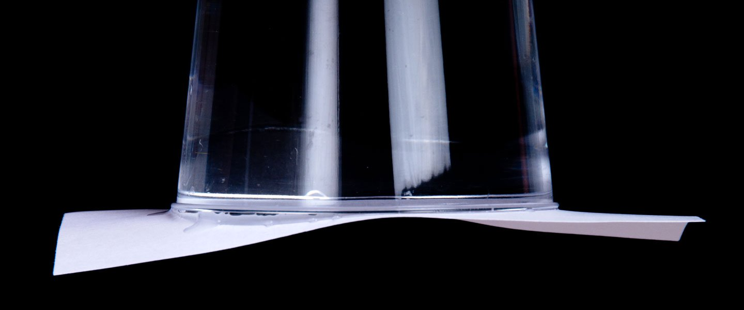

Is it scientifically possible to fill a glass with water and turn it upside down without the water spilling out like Bill did during Magic in Motion? Here is a popular science stunt that looks like magic and makes a great STEM exercise! Have students break into groups to see if they can make water defy gravity!
Students will explore the following concepts while conducting this experiment: gravity, potential energy, kinetic energy, pressure, friction, balanced forces.
You will need:
- Clear plastic cups
- Water
- Playing cards or index cards
- Bowls (just in case)
- Towels

4
1

Before you get started, make sure the index card or playing card is large enough to completely cover the mouth of the glass. Fill the glass or plastic cup to the top with water.
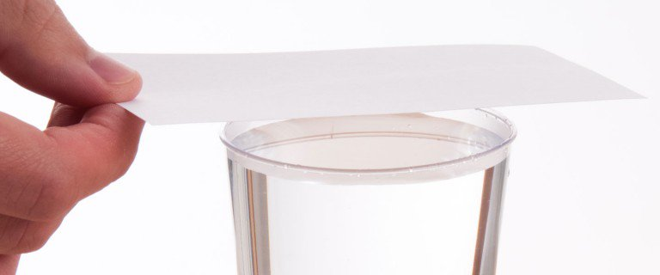
2

Cover the cup with an old playing card, making sure that the card completely covers the mouth of the container.
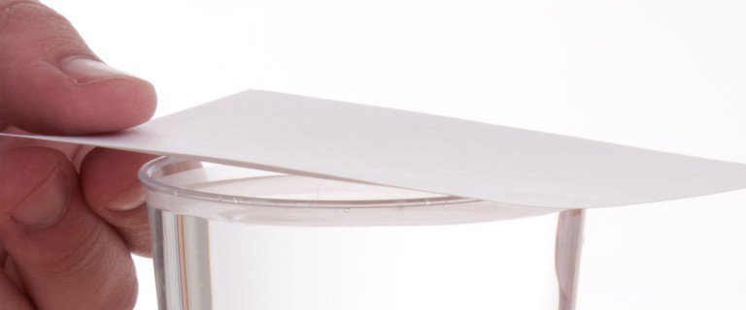
3

Keep your hand on the card and turn the cup upside down. Hold the cup over the bowl just in case you accidentally spill.
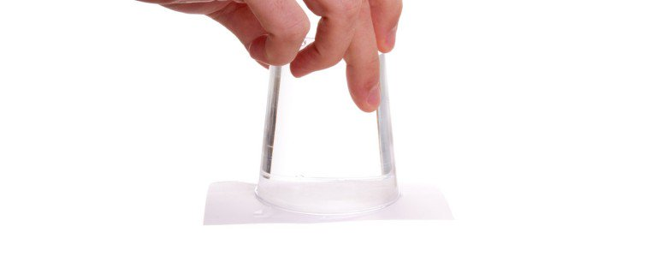

The final step takes guts. Slowly take your hand away and the card will stay in place . . . and so should the water (keep your fingers crossed).

5

Don’t press your luck too far. Put your hand hand back on the card and return the cup to its upright position.
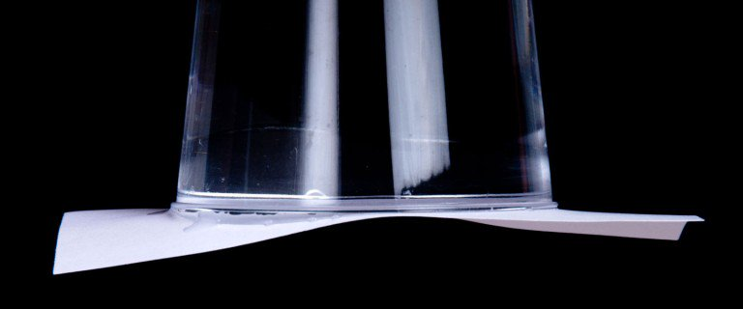
6

If the temptation is just too great, and you want to do it again. Just make sure the card doesn’t become completely soaked and accidentally fall apart. This could be a huge surprise for everyone in class.

The secret is right in front of your nose—it’s the air that we breathe. Air molecules in the atmosphere exert pressure on everything. Scientists know that at sea level air molecules in the atmosphere exert almost 15 pounds of pressure (okay, 14.7 pounds if you want to be exact) per square inch of surface area. Your body is used to feeling this kind of air pressure, so you don’t notice it.
HOW DOES IT WORK
When you first turn the cup upside down, the pressure of the air inside the cup and the air pressure outside the cup are equal (balanced force). If you look closely, however, you’ll notice that just a little water leaks out between the card and the cup. This happens because the force of gravity naturally pulls down on the water. When some of the water escapes, this causes the volume of air (the space above the water inside the cup) to increase slightly. Even though the amount of air above the water stays the same, the volume occupied by the air is now greater and the air pressure inside the cup decreases. The pressure of the air outside the cup is now greater than the pressure inside the cup and the card stays in place (potential energy). All of this is possible because the water creates an airtight seal (friction) between the rim of the cup and the card.
When the seal is broken (even a tiny bit), air enters into the cup, equalizes the pressure, and gravity pushes the water out (kinetic energy). Poking a thumbtack-size hole in the cup allows air to seep into the cup from the outside. The pressure of the air molecules both inside and outside the cup stays the same, gravity takes over, the card falls, and the water spills.
FURTHER EXPLORATION
Repeat the experiment but this time change the amount of water in the cup. Does it make any difference? What about if you switch the container? Will a wider cup hold the card better than a narrower cup? Does the temperature of the water have any effect on the water staying inside the cup?
Try the experiment using a paper cup or plastic cup but this time, using a thumbtack, poke a small hole in the bottom of the cup. What do you predict will happen if air is allowed to sneak into the cup? What if you cover the hole and then perform the trick? Does it work? What happens when you stop covering the hole?

Resources for this guide include:

The Magic of Bill Blagg Live!

Shaw Entertainment Group

Graffiti Writing Strategy https://goalbookapp.com/toolkit/strategy/graffiti-boards

Project Zero: Visible Thinking Routines

Next Generation Science Standards

Brittanica Kids

This guide was created in association with Kim Dennison. Thank you Kim for your research and development that made this study guide possible!

